E-SURREY DISPLAY COMPLETE MANUAL

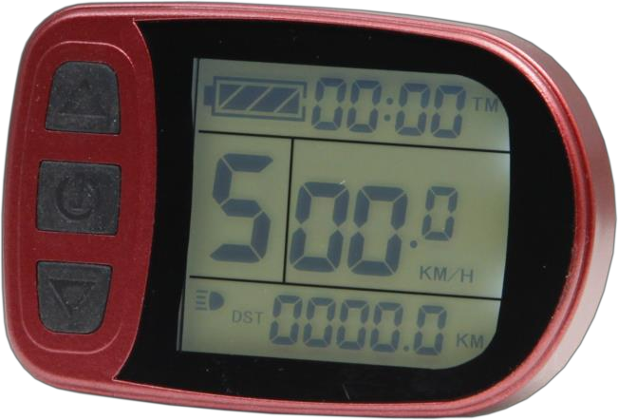

Contents

Preface 4
Outlook and Size 4
Meter Dimension 4
Main Material and Color 4
Wiring Schematic 4
Installation Instruction 4
Function Overview 5
Display Content 5
Normal Operation 6
On/Off 6
Display Interface 6
Display 1 6
Display 2 7
Display 3 8
Display of Power-assist Start-up 9
PAS Ratio Gear Switch 10
Cruise Function 10
Turn On/Off Headlight 11
Battery Capacity Indicator 11
Single Data Clearing 12
Automatic Prompt Interface 12
Error Code Display 13
User Project Setting 13
General Project Setting 13
Maximum Trip Speed 13
Wheel Diameter 14
Metric and Imperial Units 14
Exit General Project Setting 15
P Parameter Setting 16
P1 Motor Characteristic Parameter Setting 16
P2 Wheel Speed Pulse Signal Setting 16
P3 Power-assist Control Mode Setting 17
P4 Throttle Start-up Setting 18
P5 Power Monitoring Setting 19
Exit P Parameter Setting 19
C Parameter Setting 20
C1 Power-assist Sensor and Parameter Selection Setting 20
C2 Motor Phase Classification Coding Setting 21
C3 Power-assist Ratio Gear Initialization Setting 21
C4 Throttle Function Setting 22
C5 Controller Maximum Current Adjustment Setting 23
C6 Backlight Brightness Adjustment Setting 24
C7 Cruise Function Setting 25
C8 Undefined 26
C9 Power-on Password Setting 26
C10 Automatic Restore Default Setting 27
C11 Attribute Selection Setting 28
C12 Controller Minimum Voltage Adjustment Setting 29
C13 ABS brakes of the controller and Parameters of anti-charge control Setting 30
C14 Power-assist Tuning Parameters Setting 31
Exit C Parameter Setting 32
Parameter Copy 32
User Setting Note 33

Preface
The illustrated manual will help you understand and be familiar with the meter function, guiding you on how to operate the meter, how to set the project parameters, how to achieve the best match of the three as motor, controller and meter to improve electronic control performance of the electric motor. This manual covers installation,operation, parameter setting of the meter and how to use it properly, which help you resolve the problems appeared in practical use.

Outlook and Size

Meter Dimension
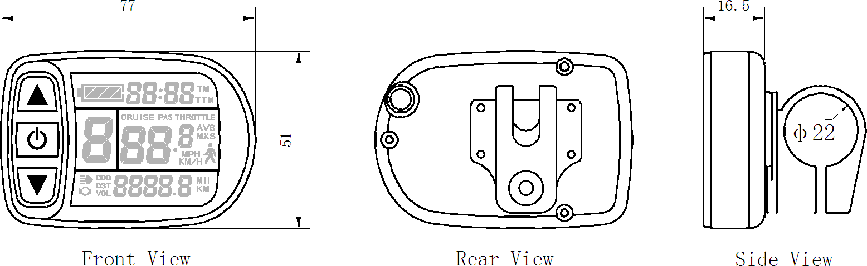

Main Material and Color
PC material is mainly used for the meter, and the housing color is dark gray.

Wiring Schematic
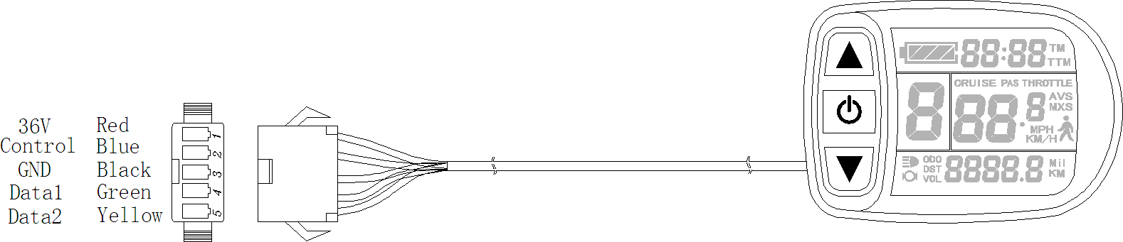

Installation Instruction
The meter body and button box are mounted on the handlebars of the surrey, adjusting perspective. In the case that the surrey is power off, the meter connectors are in plug connection to corresponding controller connectors. Turn on the power, surrey and meter will be under normal operation, the meter installation is finished. The protection film on meter display panel should be torn.

Function Overview
The meter provide you with a variety of functions such as surrey controls and surrey status digitized displays to meet the trip demands.
- Trip time display (with displays of a single trip time (TM) and total trip time (TTM));
- Trip speed display (with displays of real-time speed (Km/H or MPH) and a single maximum speed (MXS) and a single average speed (AVS));
- Trip distance display (with displays of a single trip distance (DST) and total trip distance (ODO));
- Display of power-assist start-up (PAS);
- Power-assist ratio (or throttle) gear (ASSIST) switch;
- 6Km/H power assistant push ) function;
- Cruise function (CRUISE);
- Battery capacity indicator );
- Real-time battery voltage (VOL) display;
- Turn on headlight );
- Data clearing;
- Fault code display;
- User parameter setting
- 48V, 60V supply voltage can automatic identification and be compatible

Display Content
The display content is shown as follow.

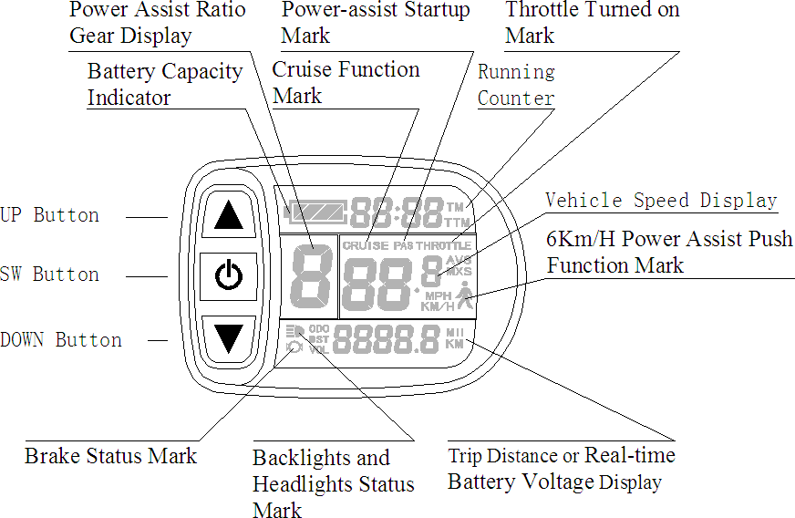
There are three keys on the display panel, icons is UP button, is SW button,
is DOWN button.

Normal Operation

On/Off
Hold button (SW) long, the meter is powered on and into normal operation, and it provides the controller with power supply. Under normal operating status, hold button (SW) long, the meter is powered off, meanwhile to shut down the power supply of controllers. When the surrey is stopped and without any button operation on the meter for five minutes, the meter will automatically shut down, and the power supply of the surrey will be powered off. In power off mode, the power consumption of the meter and controller is zero.

Display Interface
Display 1：
The meter is start-up to enter display 1.

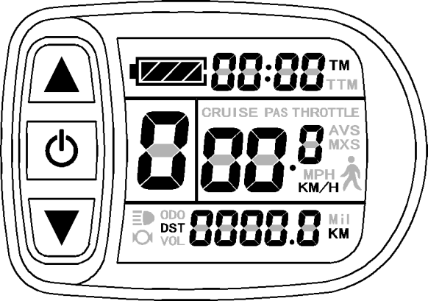
Display 1 The followings are shown on display 1.
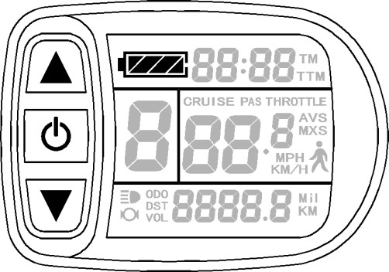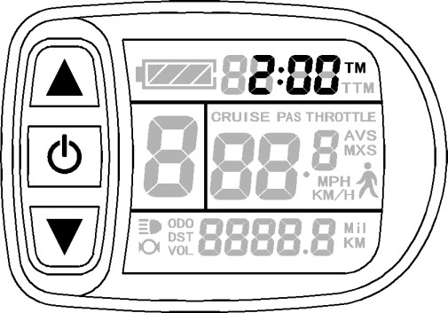
Battery Capacity Indicator Single Trip Time (TM) Display
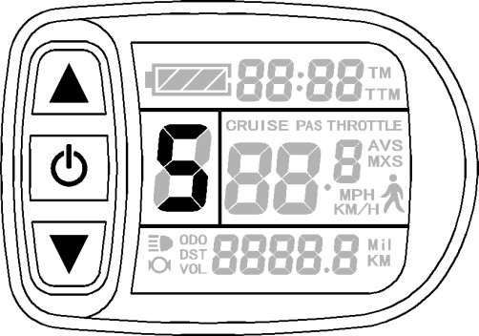
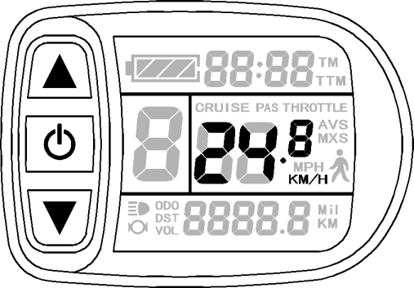
Power Assist Ratio Gear (ASSIST) Real-time Trip Speed (Km/H)

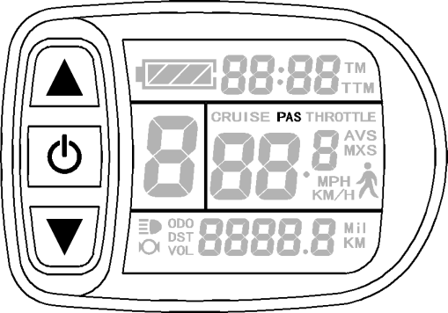
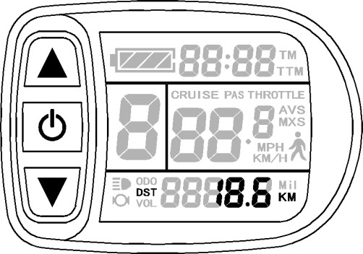
Single Trip Distance Power-assist Startup Display

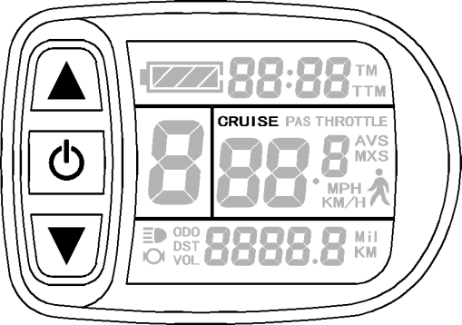
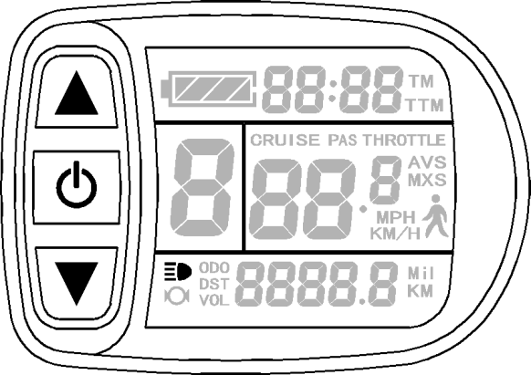
Headlights Status Cruise Function Display
Display 2：
In display 1, hold button (SW) shortly to enter display 2.
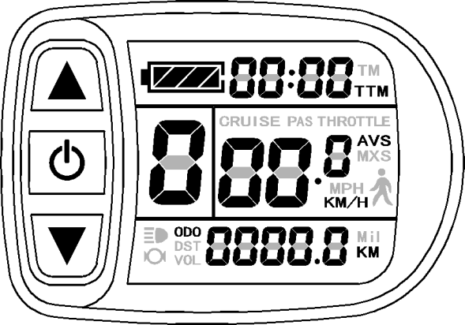
Display 2 The followings are shown on display 2:
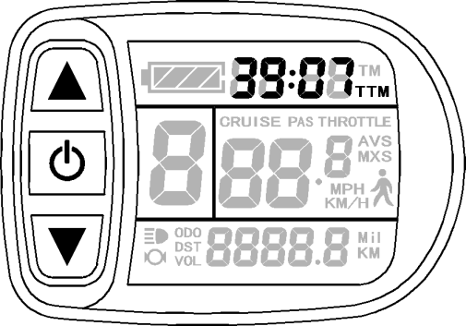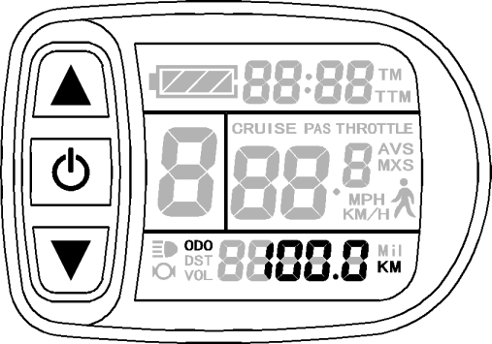
Total Trip Time (TTM) Total Trip Distance (ODO)
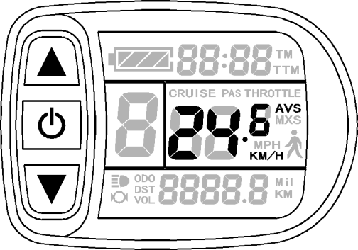
Single Average Speed (AVS)

In the riding mode after 5 seconds, display 2 automatically returns to display 1.
Display 3：
In display 2, hold button (SW) shortly to enter display 3.

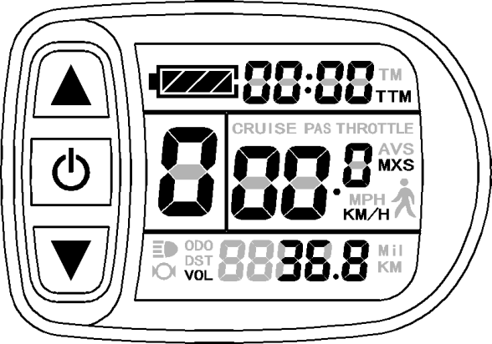

Display 3
The followings are shown on display 3.
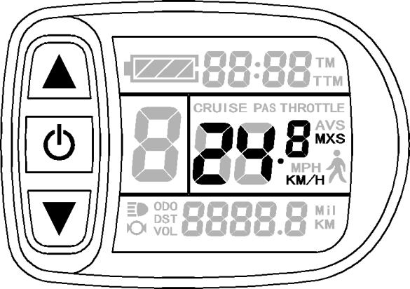
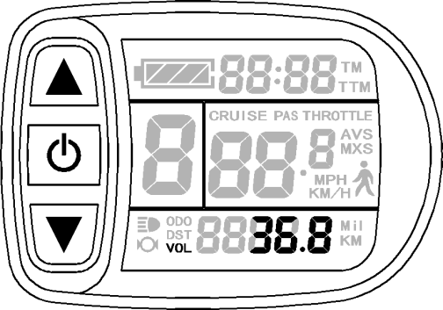

Single Maximum Speed (MXS) Real-time Voltage (VOL)

In the riding mode after 5 seconds, single maximum speed will automatically return to real-time trip speed (Km/H) as shown in the icon.
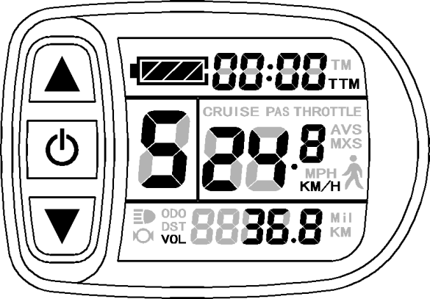
In display 3, hold button (SW) shortly again to enter display 1.

In each display interface, if you hold button (SW) long, the meter will be powered-off together with that of the controller.

Display of Power-assist Start-up
The meter is driving with power-assist under normal operating conditions, the display interface flashes the power-assist start-up sign (PAS) as shown in the figure. The sign will be off automatically after about five seconds.
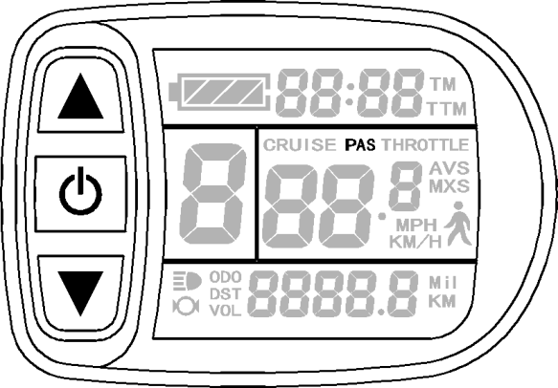

PAS Ratio Gear Switch
Under normal operation, hold button (UP) or button (DOWN) to switch the power-assist ratio gear (ASSIST), changing motor output power.Switching range is 1-5 gear (this can also be configured according to the customer requirements), gear 1 is for the lowest power, and gear 5 is for the highest power.

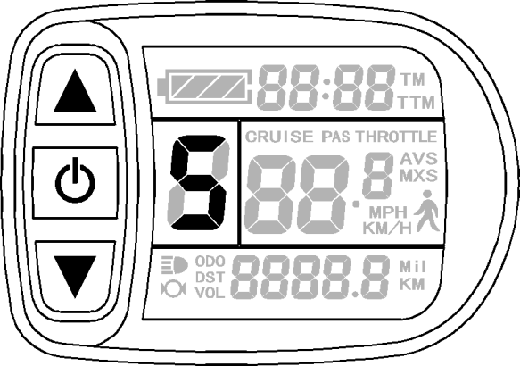

At every start-up, the meter will automatically restore gear (this can also be configured as required by users) when it was at last shut down. When the power- assist ratio is gear 0 zero, there’s no power-assist function.

Cruise Function
When C7 parameter setting is 1 (see C parameter setting), the meter turns on cruise function, hold button (DOWN) long to enter the cruise status when the vehicle speed is more than 7 km/h, and the cruise function logo (CRUISE) lights. Hold any button to revoke cruise function. Brake can not revoke cruise function for some surreys that their brakes are not connected with the controller.
Suggest not to use cruise function, because it will easy to burn the motor. The cruise function factory default is disabled.

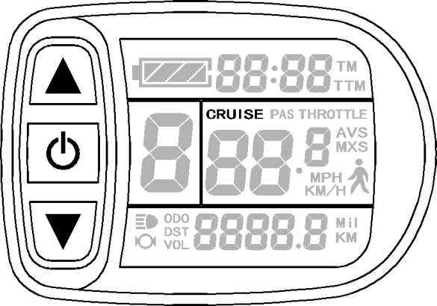

Start-up Headlights
Hold button (UP) long, the meter turns on the headlights , meter backlight and surrey lights power logo ( ) light, hold button (UP) long again to turn off backlight and surrey headlights.

Battery Capacity Indicator
The meter can automatically identify 48V, 60Vbattery capacities when it is supporting use with the specified controller. When the battery capacity is over 100%, the four power displays of the meter are lit, when the battery capacities drop, the four power displays are off in order, when the power capacity is less than 15%, the four power displays are totally turned off.
When the controller is power off due to voltage shortage, the power display frame flashes, indicating the vehicle has been in voltage shortage and waiting for shutdown currently.

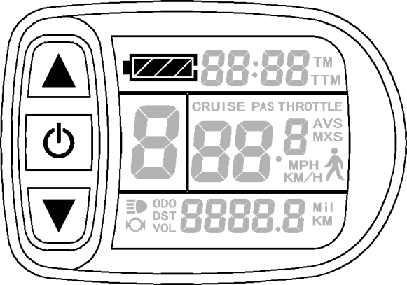

Single Data Clearing

Battery capacity indicator

Voltage shortage flashes

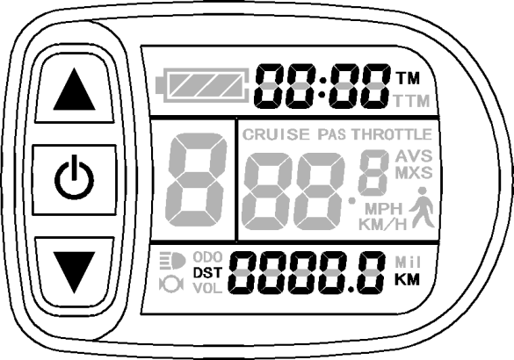
5 seconds after the meter is powered on, at display 1, hold both the button (UP) and the button (DOWN) simultaneously for about 2 seconds, the single trip time (TM) and single trip distance (DST) flicker, then hold button shortly (SW), the record contents of both will be cleared.
Single data clearing display

Under the status of data flashing, if there were no operations on the data within 5 seconds, the meter will automatically return to display1 after 5 seconds, and the original record content will be saved.
- Automatically Prompt Interface
Error Code Display：
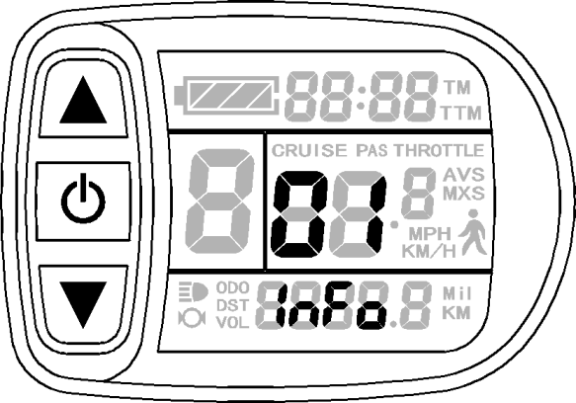
When the electronic control system of the electric surrey fails, and the meter will automatically display (flicker) fault code. You can’t exit the fault code display only the fault is removed.
Error Code Display

Error Code & Definition Table：
Error Code | Definition
01＿info | Throttle Abnormality
03＿info | Motor Hall Signal Abnormality
04＿info | Torque sensor Signal Abnormality
05＿info | Axis speed sensor Abnormality(only applied to torque sensor )
06＿info | Motor or controller has short circuit Abnormality

User Setting Project
The meter user setting project：
- General project setting
- P parameter setting
- C parameter setting

General Project Setting

Maximum Trip Speed
Under power off status, hold button long (SW), the meter is turned on. Within
5 seconds after boot-up, hold button (UP) and button (DOWN)
simultaneously for about 2 seconds, the first is to enter the maximum riding speed setting
interface, then the speed display column flashes. Hold button shortly (UP) or button (DOWN) in order to set the maximum riding speed value. The default maximum riding speed value was 20Km/h. When the speed of the electric surrey exceeds the set value, the motor will be stopped driving.
Setting interface of maximum trip speed

Under the setting maximum riding speed interface, if there’s no button operation on the meter for more than 1 minute, and then the meter will automatically return to display 1, and the original set values will be saved.
After finishing the maximum riding speed setting, hold button shortly (SW) to save the current set values and enter into the next setting.

Wheel Diameter
After finishing the maximum riding speed setting, enter the wheel diameter setting
interface, and then the wheel diameter display column flashes. Hold button (UP) or button (DOWN) to choose the corresponding wheel diameter specification to a
selected vehicle. The selection range of wheel diameter specifications are 13 species such as 6,8,10,12,14,16,18,20,22,23,24,26 and 28 inches.
The factory default is 23 inches.

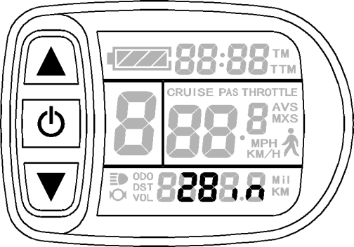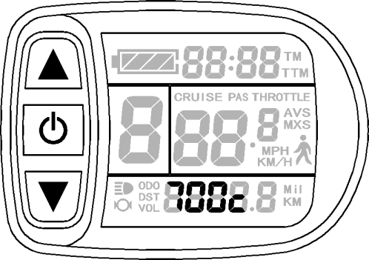

Setting Interface of Wheel Diameter

Under the wheel diameter setting interface, if there’s no button operation on the meter for more than 1 minute, and then the meter will automatically return to display 1, and the original set values will be saved.
After finishing the wheel diameter setting, hold button (SW) shortly to save the current set specification and enter into the next setting.

Metric and Imperial Units
After finishing the wheel diameter setting, enter into the metric/imperial units setting
interface, and then the speed and mileage unit flash. Hold button (UP) or button (DOWN) shortly to make sync selection of three metric/imperial units as speed,
mileage, and the environment temperature.
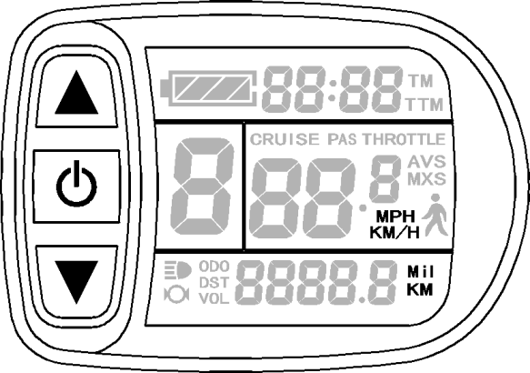
Setting Interface of Metric/Imperial Units Definition Table of Metric/Imperial Units：
Display | Metric | Imperial
Riding speed | Km/H | MPH
Total distance | Km | Mil

Under the metric/imperial units setting interface, if there’s no button operation on the meter for more than 1 minute, and then the meter will automatically return to display 1, and the original set units will be saved.
After finishing the metric/imperial units setting, hold button shortly (SW) to save the current set values, and then speed and mileage units stop flashing. Hold
button (SW) shortly again, and the meter will enter into the maximum riding speed
interface again, or hold button (SW) long for about 2 seconds to exit the general project setting environment and return to display 1.

Exit General Project Setting
Among the three general project settings, after each setting is completed, if hold button (SW) long for about 2 seconds, all can exit the setting environment and return to display 1, meanwhile, the current set parameters are saved.
Under each setting interface, if there’s no button operation on the meter for more than 1 minute, and then the meter will automatically return to display 1, and the original set parameters will be saved.

P Parameter Setting
After finishing metric/imperial unit settings, the speed and mileage units stop flashing.
Within one minute after stopping flashing, hold button (UP) and button
(DOWN) simultaneously for about 2 seconds to enter P parameter setting environment.

P1 Motor Characteristic Parameter Setting
P1 is motor characteristic parameter setting, P1 = motor gear reduction ratio× number of rotor magnet pieces, just rounding if there’s any decimal.
After entering P parameter setting environment, the first is to set P1parameter, P1
parameter column flashes. P1 setting ranges between1-255, hold button (UP) or button (DOWN) shortly for selection.

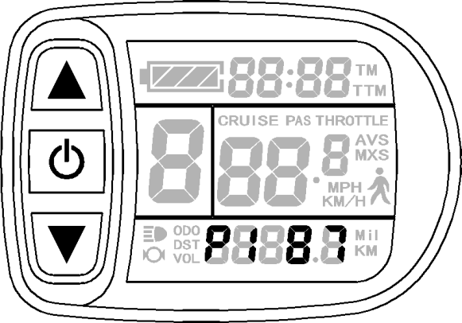

P1 parameter setting interface

Under P1 parameter setting interface, if there’s no button operation on the meter for more than 1 minute, and then the meter will automatically return to display 1, and the original set parameter will be saved.
After finishing P1 parameter setting, hold button shortly to save the current set values and enter P2 parameter setting interface.

P2 Wheel Speed Pulse Signal Setting
Enter P2 parameter setting interface after P1 parameter setting is finished, and P2 parameter column flashes.

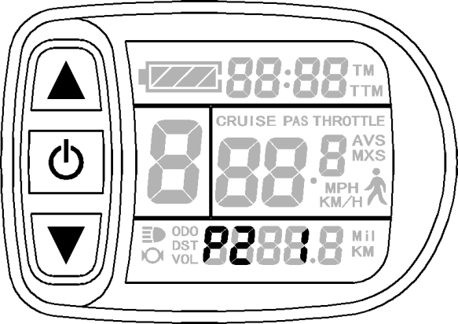

P2 parameter setting interface
P2 is wheel speed pulse signal setting, if wheel generated 1 pulse signal by a revolution, P2 should be set as1. If wheel generated 6 pulse signals by a revolution, P2 should be set as 6. If users didn’t configure the pulse signal system, and then P2 parameter setting can be 0. The setting range of P2 should be between 0-6, hold button (UP)
shortly or button (DOWN) for selection.

Under P2 parameter setting interface, if there’s no button operation on the meter for more than 1 minute, and then the meter will automatically return to display 1, and the original set parameter will be saved.
After finishing P2 parameter setting, hold button (SW) shortly to save the current set values and enter P3 parameter setting interface.
Please Note：when P2 parameter is set to be 0, for the built-in clutch motor, there will
be the following defects, when the internal motor rotors stop or the internal rotor speed is lower than the outer rotor speed, then the speed displayed on the meter is inaccurate!

P3 Power-assist Control Mode Setting
Enter P3 parameter setting interface after P2 parameter setting is finished, and P3 parameter column flashes.
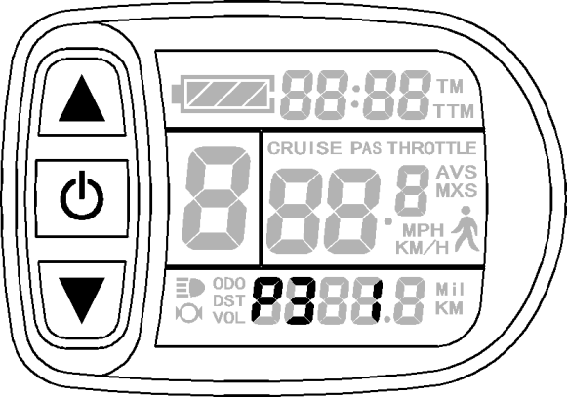
P3 parameter setting interface
P3 is for power-assist control mode setting, when P3 parameter setting is1, power- assist control mode is gear 5 of "imitation torque control" mode, when P3 parameter setting is 0, power-assist control mode is gear 5 of "speed control" mode. P3 parameter needs to be determined according to the distributed function of the controller, its setting
range is 0 or 1, hold button (UP) shortly or button (DOWN) for selection. P3 parameter setting method is the same to that of P2.

P4 Throttle Start-up Setting
Enter P4 parameter setting interface after P3 parameter setting is finished, P4 parameter column flashes.

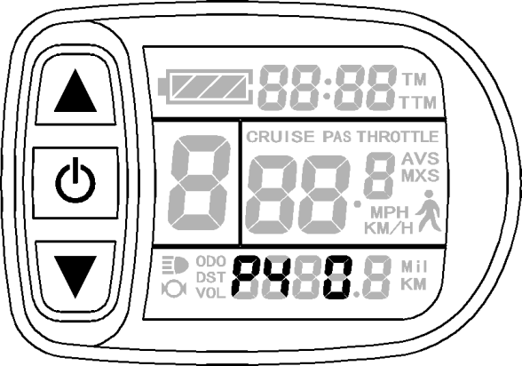

P4 parameter setting interface
P4 is throttle start-up setting, when P4 setting is 1, indicating the throttle is under "non-zero start-up" mode, namely, the throttle can be effective only after start-up the foot power assist. When P4 setting is 0, indicating the throttle is under "zero start-up" mode, the motor can be start-up by the throttle control handle directly. P4 setting range is 0 or 1,
hold button (UP) or button (DOWN) shortly for selection. P4 parameter setting method is the same to that of P2.

P5 Power Monitoring Setting
Enter P5 parameter setting interface after P4 parameter setting is finished, P5 parameter column flashes.
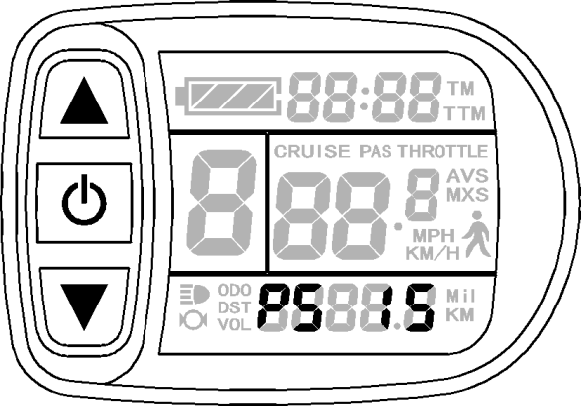
P5 parameter setting interface
P5 is power monitoring setting, when P5 setting is 0, the power monitoring is the "real-time voltage" mode. Namely, it is the method to determine the battery capacity based on real-time battery voltage. When P5 equals to a specified parameter, the power monitoring is the "smart power" mode (this parameter is determined by the battery
characteristics, ordinary 48V lithium is generally is 6-20,60V lithium is generally is 7-25 ). P5

setting ranges from 0-40, hold button (UP) or button (DOWN) shortly for selection. P 5 parameter setting method is the same to that of P2.
After finishing P5 parameter setting, hold button (SW) shortly to save current set the values, and then P5 parameter column stops flashing. Hold button (SW) shortly again, the meter re-enter P1 parameter setting interface. Or hold button (SW) long for about 2 seconds to exit P parameter setting environment and return to the display 1.

Exit P Parameter Setting
Among the five P parameter settings, when each parameter setting is completed, if
held button (SW) long for about 2 seconds, all can exit the setting environment and return to display 1, meanwhile, the current set parameters would be saved.
Under each parameter setting interface, if there’s no button operation on the meter for more than 1 minute, and then the meter will automatically return to display 1, and the original set parameters will be saved.

C Parameter Setting
After finishing P5 parameter setting, P5 parameter column stops flashing. Within 1
minute after stopping flashing, hold button (UP) and button (DOWN) for about 2 seconds to enter C parameter setting environment.

C1 Power-assist Sensor and Parameter Selection Setting
Set C1 parameter first after entering C parameter setting environment, C1 parameter column flashes.
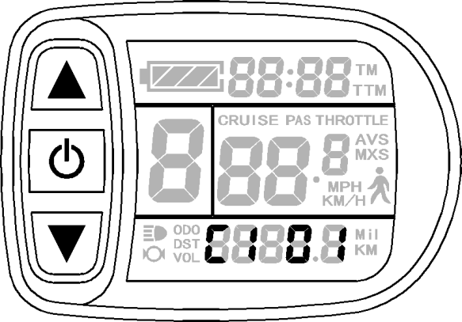

C1 parameter setting interface
C1 is power-assist sensor and parameter selection setting, its definition is shown in
following table. C1 setting ranges between 0-7, hold button (UP) or button (DOWN) for selection.
C1 parameter definition table：
Forward assist sensors | C1  value | Start  Sensitivity | Reverse assist sensors | C1  value | Start  Sensitivity
Forward 5 Signal | 00 | Standard | Reverse 6 Signal | 05 | Standard
 | 01 | Lower |  | 06 | Lower
 | 02 | Lowest |  | 07 | Lowest
Forward 8 Signal | 00 | Higher | Reverse 10 Signal | 05 | Higher
 | 01 | Standard |  | 06 | Standard
 | 02 | Lower |  | 07 | Lower
Forward 10 Signal | 00 | Highest | Reverse 12 Signal | 05 | Highest
 | 01 | Higher |  | 06 | Higher
 | 02 | Standard |  | 07 | Standard

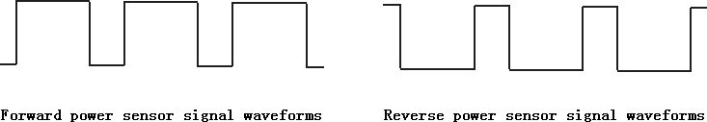
After finishing C1 parameter setting, hold button (SW) shortly to save the current set values and enter C2 parameter setting interface.

C2 Motor Phase Classification Coding Setting
Enter C2 parameter setting interface after C1 parameter setting is finished, C2 parameter column flashes.
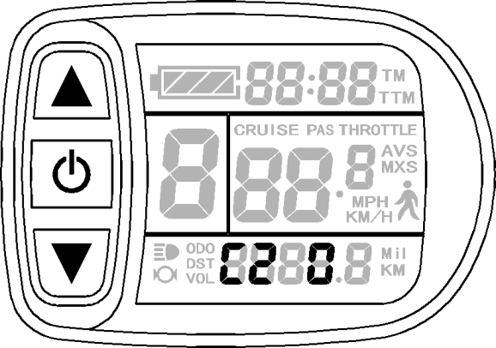

C2 parameter setting interface
C2 is motor phase classification coding setting, it is served as identification parameter of different phases of the motor when using sine wave drive and the default value is 0. When C2 setting is 0, indicating that the used Quantum motor phase is an ordinary one. When the setting is a certain value, indicating a particular motor phase is used. C2 setting range is 0-7, hold button (UP) or button (DOWN) for selection.
After finishing C2 parameter setting, hold button (SW) shortly to save the
current set values and enter C3 parameter setting interface.

C3 Power-assist Ratio Gear Initialization Setting
Enter C3 parameter setting interface after C2 parameter setting is finished, C3 parameter column flashes.
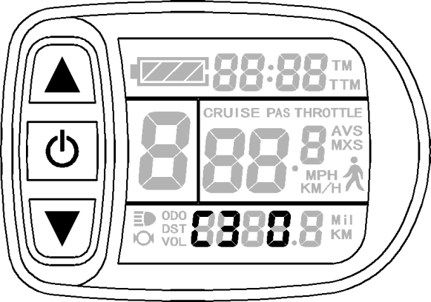
C3 parameter setting interface
Hold button (UP) or button (DOWN) for selection C3 parameter values.
The factory default is 8. C3 parameter values：
C3 | Parameter value meaning
0 | The meter is powered on and the power-assist ratio is at gear 0.
1 | The meter is powered on and the power-assist ratio is at gear 1.
2 | The meter is powered on and the power-assist ratio is at gear 2.
3 | The meter is powered on and the power-assist ratio is at gear 3.
4 | The meter is powered on and the power-assist ratio is at gear 4.
5 | The meter is powered on and the power-assist ratio is at gear 5.
6&7 | Retain
8 | Each start-up will automatically restore the gear shutdown last time.

After finishing C3 parameter setting, hold button (SW) shortly to save the current set values and enter C4 parameter setting interface.

C4 Throttle Function Setting
Enter C4 parameter setting interface after C3 parameter setting is finished, C4 parameter column flashes.
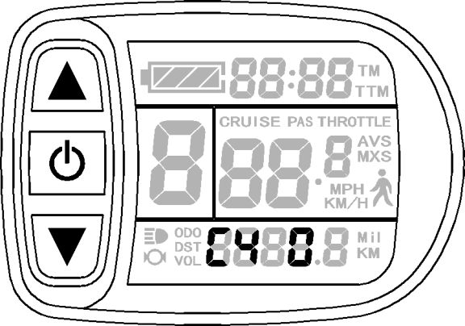
C4 parameter setting interface
C4 is throttle function setting, the setting range is 0-4, hold button (UP) or button (DOWN) for selection.
C4 parameter definition table：

C4 value | P4=0 | P4=1
0 | zero start-up throttle | Non-zero start-up throttle
1 | Zero start-up, throttle speed limit is 6Km/h, | Before power-assist, the throttle speed limit is 6Km/h, after power-assist, throttle is full speed.
2 | Zero start-up, throttle speed limit is  specified | Non-zero start-up, throttle is specified speed limit.
3 | Zero start-up, Zero gear effectively | Before power-assist, the throttle speed limit is 6Km/h, after power-assist, throttle is full speed.  Stop power-assist, return the throttle speed limit is  6Km/h.
4 | Throttle gears is distinguished  according to the display meter. | Non-zero start-up throttle, Throttle gears is  distinguished according to the display meter.
5 | Retain | Retain

When C4 = 2 is confirmed, "specified speed limit value of throttle" flashes, press
(UP) button or (DOWN) button for short to make selection, and the default value is 20.
When C4 = 4 is confirmed, the "percentage value of the first gear speed accounts for its full speed" of the power-assist gear flashes, press (UP) button or
(DOWN) button for short to make selection, and the default value is 50%. The percentage values of other gears divide automatically in equal.
After finishing C4 parameter setting, hold button (SW) shortly to save the current set values and enter C5 parameter setting interface.

C5 Controller Maximum Current Adjustment Setting
Enter C5 parameter setting interface after C4 parameter setting is finished, C5 parameter column flashes.
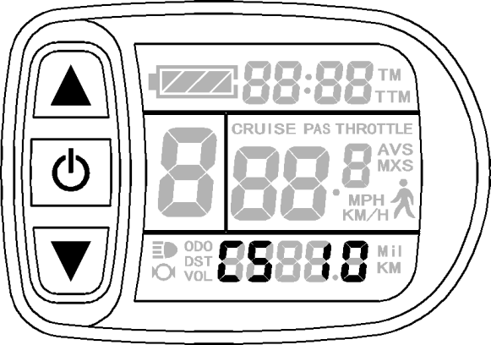
C5 parameter setting interface
C5 is controller maximum operating current adjustment setting (tiny-adjustment of
limit current value), the default value is 10, setting range is 0-10, hold button (UP) or button (DOWN) shortly for selection.
C5 parameter definition table：
C5 value | Maximum current value(A)
00 | Three level slow start/ Maximum current value
01 | Two level slow start/ Maximum current value
02 | One level slow start/ Maximum current value
03 | Maximum current value÷2.00
04 | Maximum current value÷1.50
05 | Maximum current value÷1.33
06 | Maximum current value÷1.25
07 | Maximum current value÷1.20
08 | Maximum current value÷1.15
09 | Maximum current value÷1.10
10 | Maximum current value
When C5 setting is 10, maximum current value is controller maximum operating current value (ie, limit current value); when setting is 9, maximum current value divided by 1.10, when setting is 8, maximum current value divided by 1.15 and so on.
After finishing C5 parameter setting, hold button (SW) shortly to save the current set values and enter C6 parameter setting interface.

C6 Backlight Brightness Adjustment Setting
Enter C6 parameter setting interface after C5 parameter setting is finished, C6 parameter column flashes.

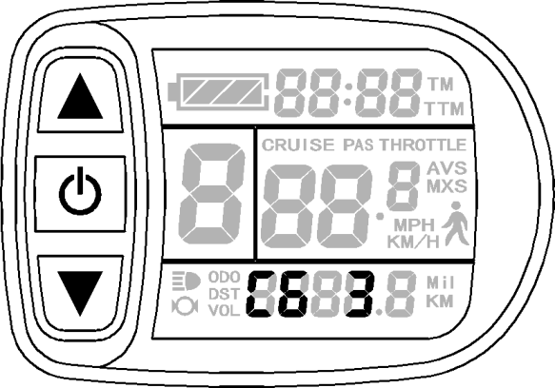

C6 parameter setting interface
C6 is the meter backlight brightness adjustment setting, the default value is 3, and
setting range is 1-5, hold button (UP) or button (DOWN) shortly for selection.
C6 parameter definition table：
C6 value | Backlight brightness
1 | Dimmest
2 | Darker
3 | Standard
4 | Brighter
5 | Brightest
After finishing C6 parameter setting, hold button (SW) shortly to save the current set values and enter C7 parameter setting interface.

C7 Cruise Function Setting
DO NOT ENABLE Cruise function! It can be dangerous since it bypasses the pedal sensor and your bike could take off with out any one in control of it. It can also reduce the stopping time when braking if the motor is not disengaged with the LED display timely. Enabling this setting will void any warranties and Beach Surrey Bikes and its affiliates will assume no liability for injuries or death.
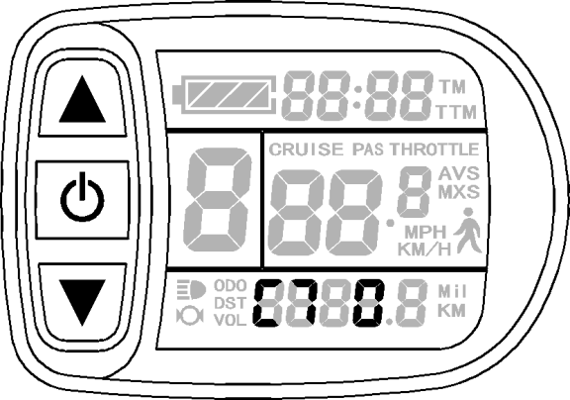
Enter C7 parameter setting interface after C6 parameter setting is finished, C7 parameter column flashes.
C7 parameter setting interface
C7 is cruise function setting, the setting range is 0 or 1, hold button (UP) or button (DOWN) shortly for selection.
C7 parameter definition table：
C7 value | Cruise function
0 | Off
1 | On
After finishing C7 parameter setting, hold button (SW) shortly to save the current set values and enter C8 parameter setting interface.The factory default is 0.

C8 Undefined
Enter C8 parameter setting interface after C7 parameter setting is finished, C8=0.
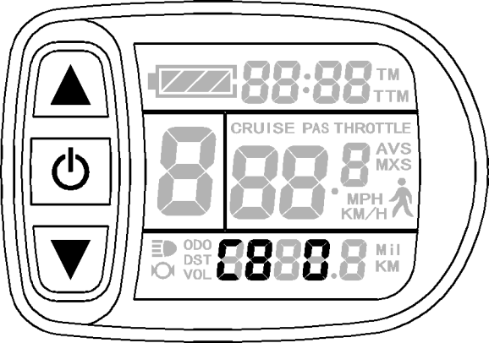
C8 parameter setting interface
C8 is not defined temporarily. Hold button (SW) shortly to enter C9 parameter setting interface.

C9 Start-up Password Setting
Enter C9 parameter setting interface after C8 parameter setting is finished, C9 parameter column flashes.
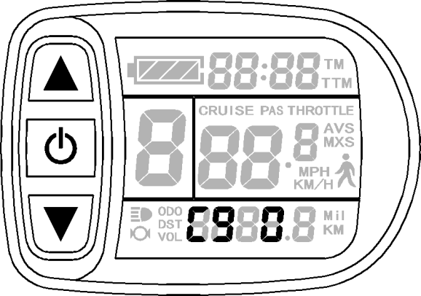
C9 parameter setting interface
C9 is meter power-on password setting, the default value is 0, hold button (UP)
or button (DOWN) shortly for selection. C9 parameter definition table：
C9 value | Start-up password setting
0 | Function off
1 | Function on

When C9 setting is 1, hold button (SW) shortly, indicating that the password function is start-up, and then enter the password settings interface, three password setting columns flash.
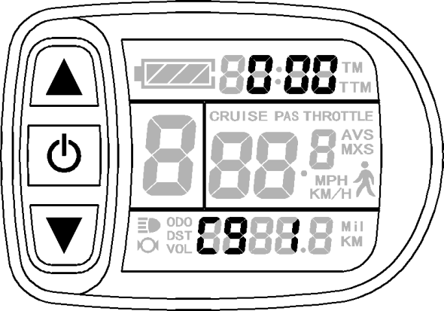
Password Setting Interface
The password setting is done sequentially from left to right, hold button shortly
to confirm after each setting and enter next setting. Password setting range is 000-999, hold
button (UP) or button (DOWN) shortly for selection.
Please note：If you forget your password, the parameters can only be copied (see parameter copy) by data source meter prier to be decoded.
After finishing C9 parameter setting, hold button (SW) shortly to save the current set values and enter C10 parameter setting interface.

C10 Automatically Restore Default Setting
Enter C10 parameter setting interface after C9 parameter setting is finished, C10 parameter column flashes.
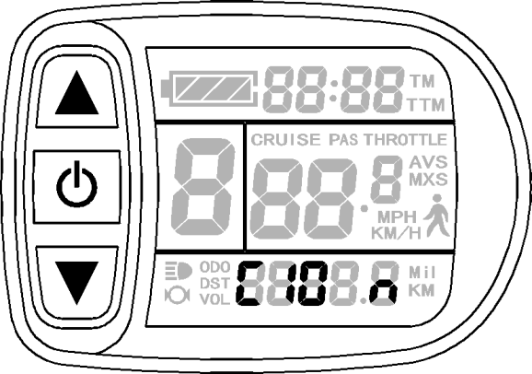
C10 parameter setting interface
C10 is automatic restore default settings, the default is n, and the setting can be n, or y,
hold button (UP) or button (DOWN) shortly for selection. C10 parameter definition table：
C10 value | Restore default setting
n | Function off
y | Function on

When the meter is needed to restore default setting, C10 selects y, hold button long for about 2 seconds, all parameters restore default settings and exit setting environment, and then return to the display1.
C10 selects n, hold button (SW) shortly to save the current set values and enter C11 parameter setting interface.

C11 Attribute Selection Setting
Enter C11 parameter setting interface after C10 parameter setting is finished, C11 parameter column flashes.
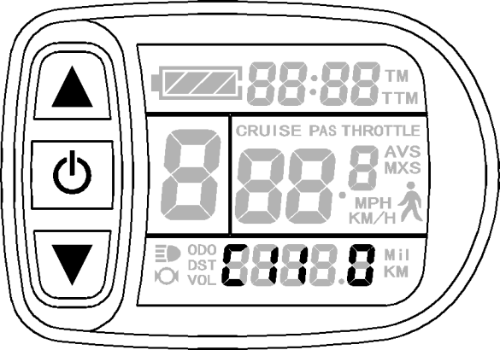
C11 parameter setting interface
C11 is meter attribute selection setting, the setting range is 0-2, hold button
(UP) or button (DOWN) shortly for selection. The factory default is 0.
C11 selects 2, hold (SW) long for about 2 seconds to exit the setting environment, and then the meter is served as data source for copying parameter (see parameter copy), there’s source logo on display interface.

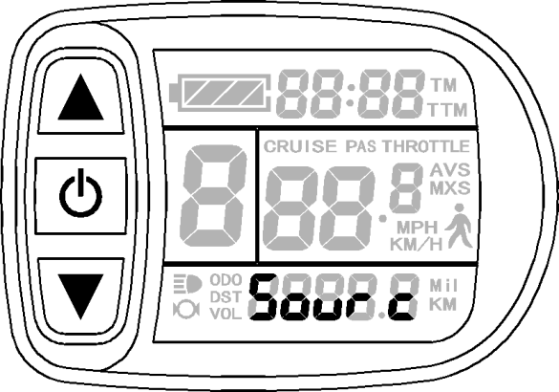

Data Source Display Interface
After finishing C11 parameter setting, hold button (SW) shortly to save the current set values and enter C12 parameter setting interface.

C12 Controller Minimum Voltage Adjustment Setting
Enter C12 parameter setting interface after C11 parameter setting is finished, C12 parameter column flashes.
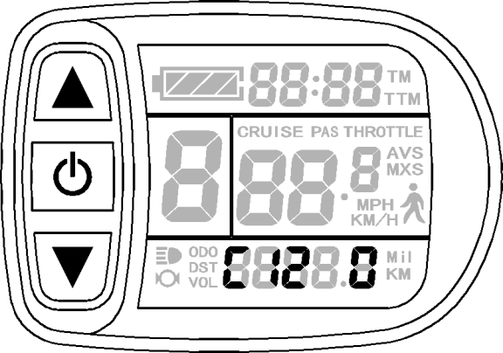
C12 parameter setting interface
C12 is controller minimum operating voltage adjustment setting (tiny adjustment of voltage shortage), the default value is 4, and the setting range is 0-7, hold button
(UP) or button (DOWN) shortly for selection.
C12 parameter definition table：
C12 value | Minimum Voltage(V)
 | 36V Controller | 48V Controller | 60V Controller
0 | Default value-2V | Default value-2V | Default value-2V
1 | Default value-1.5V | Default value-1.5V | Default value-1.5V
2 | Default value-1V | Default value-1V | Default value-1V
3 | Default value-0.5V | Default value-0.5V | Default value-0.5V
4 | Default value 30V | Default value 40V | Default value 50V
5 | Default value+0.5V | Default value+0.5V | Default value+0.5V
6 | Default value+1V | Default value+1V | Default value+1V
7 | Default value+1.5V | Default value+1.5V | Default value+1.5V

C12 default value is 4, namely, controller minimum operating voltage (voltage shortage value); when setting is 5, the default value plus 0.5V, when setting is 4, the default value minus 0.5V and so on.
After finishing C12 parameter setting, hold button (SW) shortly to save the current set values and enter C13 parameter setting interface.

C13 ABS brakes of the controller and parameters of anti-charge control Setting
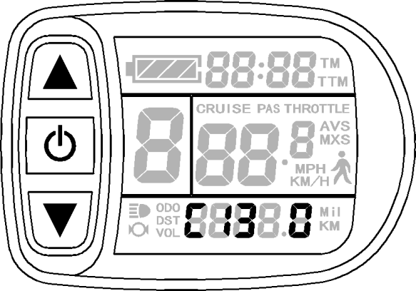
Enter into C13 parameter setting interface, C13 parameter bar flashes.
C13 parameter setting interface

C13 is ABS brakes of the controller and parameters of anti-charge control setting, the default value is 0 with the setting range between 0-5, press (UP) button or

(DOWN) button to make selection.
C13 parameter definition table:
C13 Value | ABS braking strength | Energy recovery efficiency
0 | None | None
1 | Class 1 braking strength | Best energy recovery efficiency
2 | Class2 braking strength | General energy recovery efficiency
3 | Class 3 braking strength | Weaker energy recovery efficiency
4 | Class4 braking strength | Poor energy recovery efficiency
5 | Class5 braking strength | Bad energy recovery efficiency

The factory default is 0, other values need to be chosen with caution for use.
Be sure to note: the higher is the braking intensity level, and the braking strength

will be greater, the greater damage to the motor shaft accordingly.
After finishing the parameter setting of C13, press (SW) button for short to enter C14 parameter setting interface.

C14 Power-assist Tuning Parameters Setting
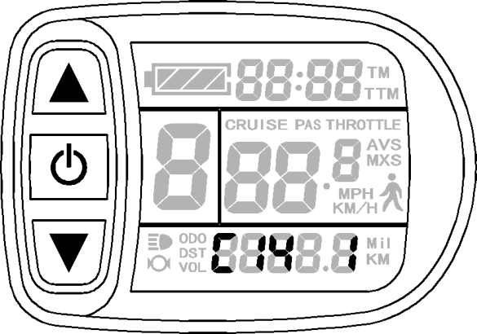
Enter into C14 parameter setting interface, C14 parameter bar flashes.
C14 parameter setting interface
C14 is the parameters of power-assist tuning setting, with the default value of 2. The power-assist is between1-4 gear, and it is invalid until P3 equals to 1. The setting range 1-3, and press (UP) button (DOWN) button for short to make selection.

C14 parameter definition table:
C14 Value | Assist strength of intelligent pedal motor
1 | Weak assist strength of motor
2 | General assist strength of motor
3 | Stronger assist strength of motor
After finishing C14 parameter setting, hold button (SW) shortly to save current set values and enter C1 parameter setting interface again. Or hold button (SW) long for about 2 seconds to exit C parameter setting environment and return to the display 1.

Exit C Parameter Setting
Among the fourteen C parameter settings, when each parameter setting is completed,
if held button (SW) long for about 2 seconds, all can exit the setting environment and return to display 1, meanwhile, the current set parameters would be saved.
Under each parameter setting interface, if there’s no button operation on the meter for more than 1 minute, and then the meter will automatically return to display 1, and the original set parameters will be saved.

Parameter Copy
Set parameters (include general project parameter, P parameter and C parameter) of all meter produced by our company according to requirements, and set the meter to be a data source according to the method of "C11 Attribute Selection Setting".
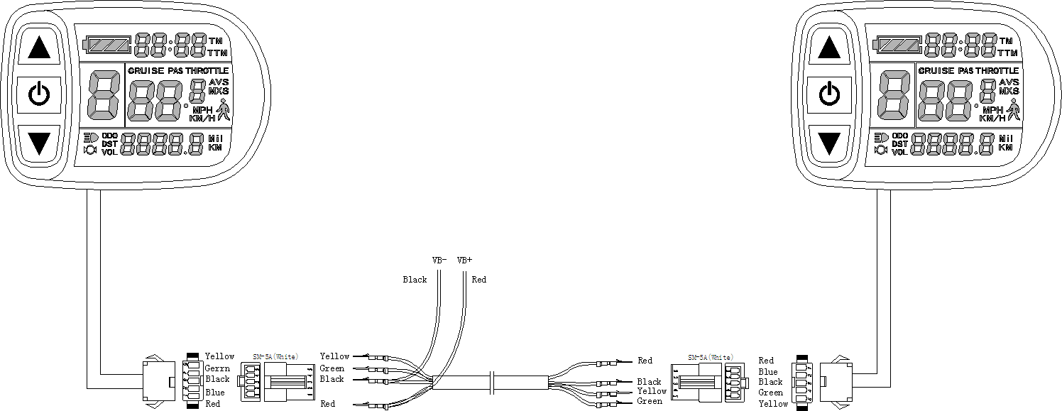
Use special wiring cables to properly wire to the meter needs to be copied according to the diagram.

Meter parameter copy wiring diagram

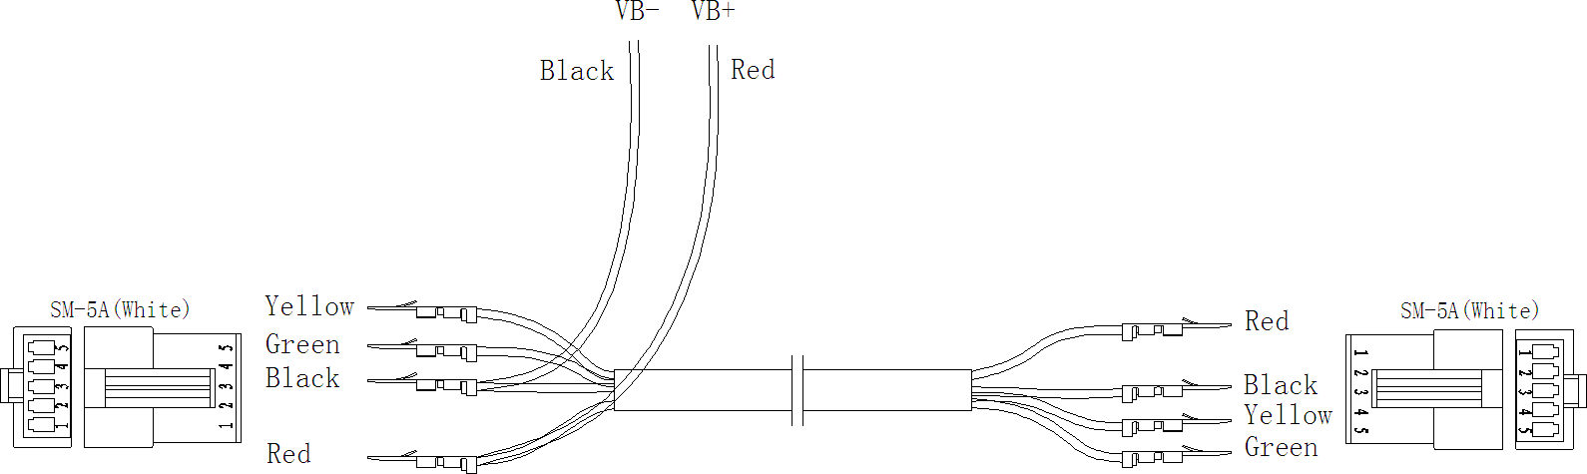

Special wiring cable
Turn on meter power supply of data source. Power supply of 60V is available (VB + positive power supply). After wiring the meter needs to be copied, hold button long till meter is start-up. Within 5 seconds after start-up, hold button(UP) and button (DOWN) simultaneously for about 2 seconds, meter parameter copy is completed. If the copy operation is correct, the meter subject to be copied will display as follow.
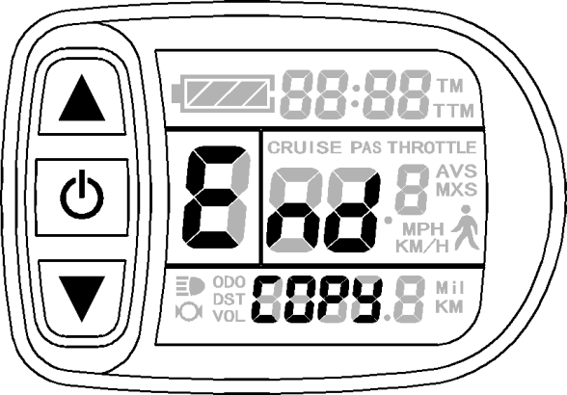
Interface of finishing parameter copy

Please note: Both C9 power-on password and C11 meter attributes can’t be copied.

User Setting Note
After entering the user setting environment, if there’s no button operation on the data for more than 1 minute, the meter will automatically return to display1, and the new set parameters won’t be saved.
The factory parameter set value and the default value of the meter can be set according to user requirements, the meter parameter can be restored by using “C10
Automatically Restore Default Setting” approach when adjusting it.

